TECH STACK
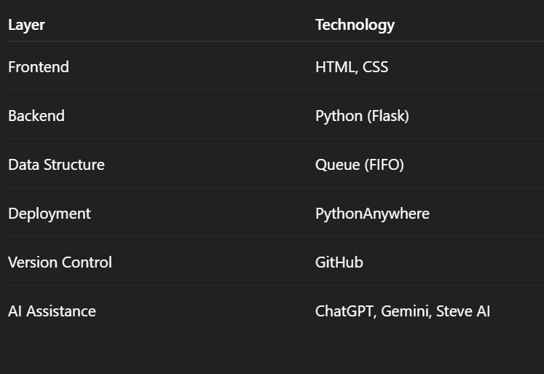
🖥️ Frontend Layer
The frontend was built using HTML and CSS to display food items, categories, and order forms.
It focuses on simplicity, usability, and visual appeal for students.
Interactive elements and animations improve the user experience without making the interface complex.

⚙️ Backend Layer
The backend is developed using Python with Flask, which handles routing and request processing.
It connects the frontend with the application logic and sends appropriate responses.
Flask was chosen for its lightweight nature and ease of integration with Python logic.

🧮 Data & Logic Layer
This layer uses a queue (FIFO) data structure to manage cafeteria orders.
Each cafeteria maintains its own queue to simulate real-life waiting lines.
The queue length is used to calculate estimated preparation time and generate token numbers.

☁️ Deployment Layer
The application is deployed on PythonAnywhere, a cloud platform designed for Python applications.
It provides a permanent public URL and ensures the app runs continuously.
This makes the project easily accessible to judges without requiring local setup.

🤖 AI Assistance Layer
AI tools such as ChatGPT and Gemini were used for understanding concepts, debugging, and verification.
Steve AI was used to assist in presentation and visual explanation of the project.
AI tools were used only as supportive aids.

